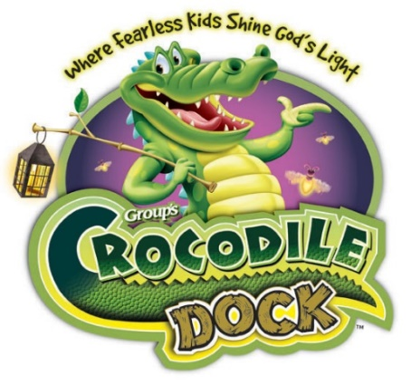
Trinity Lutheran Church
Student
Registration
Form
(one per child, please)

Cost is $10.00 for first child in family, $5 for each child after. The cost includes a t-shirt, crafts, snacks and fun for the entire week!

Child’s name: ____________________________________ Age: ____

Street Address: ______________________________ Gender:_______

City: ____________________________ State: ____ Zip: __________

Date of Birth: _____________ Last school grade completed: _______

Parent’s Cellphone: (____)___________ T-SHIRT SIZE _________

Mother’s name: _______________ Father’s name: _______________

Parent Email: _____________________________________________

Emergency Contact: ________________________________________

Allergies (food, animals, hay, etc.) or other medical conditions:

_________________________________________________________

Media Release: (Parent Initial Required)
_____ My child may appear in pictures and videos of vacation bible
school for use by the church.
_____ My child may NOT appear in pictures or videos of vacation
bible school for use by the church.

Crew number (for church use only): ________________

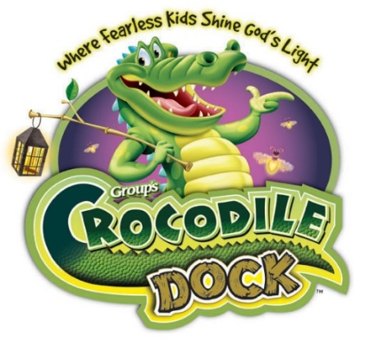
Trinity Lutheran Church
Volunteer
Registration
Form
(one per volunteer, please)

There is no cost for volunteers. You will be given a Crocodile Dock VBS staff t-shirt.

Name: __________________________________________________

Street Address: ____________________________________________

City: ____________________________ State: ____ Zip: __________

Age (if under 18): _________________ T-SHIRT SIZE _________

Cellphone: _____________________________

Email Address: ____________________________________________

Emergency Contact: ________________________________________

Area you’d like to work: _____________ Can work all 5 days: ______

Allergies (food, animals, hay, etc) or other medical conditions:

________________________________________________________

Media Release: (Parent initial required if under 18 years old)
_____ I consent to appearing in pictures and videos of vacation bible
school for use by the church.
_____ I do NOT consent to appearing in pictures or videos of vacation
bible school for use by the church.

Job assigned (for church use only): ____________________________

Trinity Lutheran Church
703 N. Main Street
Blanco, Texas 78606
(830) 833-4771

trinityblanco@gvtc.com

Sunday Service time:
9:30 a.m.

Sunday School for all Ages
10:45 a.m.

ALL ABOUT TLC VBS 2022
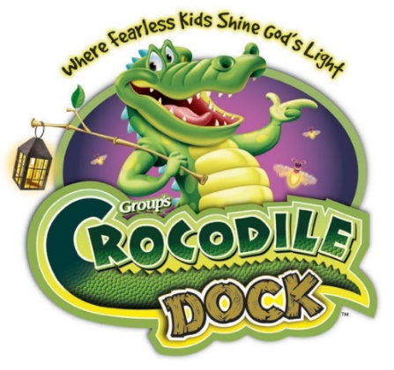
WHEN: June 6 – 10, 2022
9 a.m. until Noon

WHERE: Trinity Lutheran Church
703 N. Main,
Blanco, TX, 78606

AGES: It’s for ages 4 years through
6th grade

COST: $10.00 for first child in family, $5 for each child after. The cost includes a t-shirt, crafts, snacks and BIG fun activities for the entire week! Optional VBS music CDs will be available for $5 each. Just fill out the attached Student Registration form (one for each child, please) and mail or bring by Trinity Lutheran Church. Call if your child has special needs. We’d like to be able to accommodate them also.

LIMITED ENROLLMENT: Register early! Enrollment is limited!

VOLUNTEERS: Yes, teens and adults are needed. We’re looking for anyone who has a heart for the Lord and loves kids. There are plenty of jobs: Crew Leaders and assistants, Station Leaders and assistants, Kitchen Crew, Decorations, clerical help and much more. If you’re interested, call Trinity’s Church Office at 830-833-4771. There is no cost to be a volunteer! We supply you with an official Crocodile Dock VBS Staff t-shirt. If you would like to volunteer but will need childcare, please indicate. Please fill out the attached Volunteer Registration form and bring or mail it to Trinity Lutheran Church as soon as possible.

QUESTIONS ???
Contact Trinity by email at trinityblanco@gvtc.com or call the church office between the hours of 9 a.m. and 1 p.m. Mon. – Thurs. at (830)833-4771.

